# Purpose

This document describes how to make a worklist to run an experiment on the Hamilton STAR liquid handling robot. The experimental design described here is specifically for running and/or optimizing nucleic acid amplification tests (NAAT).

# Scope

This document applies to the Hamilton STAR liquid handling robot and its operators.

# Definitions

|  |  |
| --- | --- |
| **TERM** | **DEFINITION** |
| CSV | Comma-separated values file |
| LFA | Lateral flow assay |
| MM | Mastermix |
| NAAT | Nucleic acid amplification test |
| PPE | Personal Protective Equipment |

# Related Documents

1. Hamilton STAR Operator Manual
2. Microlab STAR Software Programmer Manual
3. DROP SOP-001: Hamilton STAR operation
4. DROP Protocol-003: Analyzing NAAT data

# Roles and Responsibilities

|  |  |
| --- | --- |
| **Role** | **Responsibility** |
| Principal User | * Establish and implement this procedure * Ensure users are adequately trained in use of this instrument * Complete Training Form and provide to Quality Manager for recordkeeping * Review procedure periodically for necessary updates |
| Instrument User | * Complete training on use of the instrument * Perform tasks as specified in procedure |
| Lab Manager | * Review procedure periodically for necessary updates |

# Environmental Health and Safety

Appropriate PPE is required for all Diagnostics Lab activities.

# Worklist Background

## The worklist is a .csv file that is input into the Hamilton Run Control to the robot what actions to follow and in what order. The worklist is a *.csv file that is input into the Hamilton Run Control to inform the robot what actions to follow and in what order.

## The file containing the worklist must end with worklist.csv otherwise the Hamilton software will not recognize it. The file containing the worklist must end with worklist.csv; otherwise, the Hamilton software will not recognize it.

## The file must be a plain .csv file (not a UTF-8 or any other csv version).

## A worklist can be made manually or by coding. For LFA optimization work, we have python-based code called the “Robot Worklist Generator”. For NAAT, we are currently developing code with an integrated user interface.

## The worklist is composed of 21 columns (two of which are optional) and infinite rows. The identity and definition of each of these columns is described in Section 8. The order of the columns does not matter.

# Worklist Column Definitions

## **step** – a text string to describe what the step is (e.g. make_MM1, mix_MM1, or aliquot_MM1)

## **volume_µL** – volume to be pipetted. Must be smaller than the volume associated with the liquid class (50, 300, or 1000 depending). If volume is set to 0, the robot will take a picture instead of pipetting nothing.

## **liquid_class** – liquid class associated with the liquid to be pipetted. These classes have been designed specifically for the liquids that we pipette and the volumes we plan to use. There is a list of possible liquid classes found in the CO-RE liquid editor. The specific liquid classes designed for NAAT can be found in the NAAT documentation.

## **tip_type** – this value is associated with the liquid class selected and the volume to be pipetted. This value will be either 50, 300, or 1000. This value needs to be larger than the volume to be pipetted.

## **dispense_type** – two dispense types, “Surface_Empty” and “Jet_Empty” are used. Surface_Empty goes to the tip of the liquid, detected using a capacitive measurement, and dispenses 2mm below that height. This feature struggles when there are bubbles at the top of a liquid. Jet_Empty goes inside the well and dispenses at a set height above the bottom of the well plate. Jet_Empty tends to be accurate at faster speeds than Surface Empty.

## **asp_mixing** – programs the number of mixing cycles performed after a dispense step. This value needs to be the same value for an entire group. This feature only works for Surface_Empty liquid classes.

## **source** – the name of the liquid that is being pipetted. By using specific descriptors, source can be useful for the user when designing the worklist.

## **group_number** – the “group” classification is an important one. Each group needs to be from the same tip_type (50, 300, 1000). The group number is used by the robot to control the order and timing of pipetting steps. It is recommended to keep groups of 8 rows if you want to control the order in which the robot completes each step.

## *Note: if one item in a group has mixing step, for example, then all items in that group will be mixed. However, using too many groups will make the method too slow. Therefore, group numbers need to be assigned wisely.*

## **timer_delta** – If the assay has time dependent steps, a value to program a time delay between the step and the next (associated) step, defined in timer_group_check. **timer_delta** – If the assay has time dependent steps, add a value to program a time delay between the step and the next (associated) step, defined in timer_group_check. The value here is in seconds.

## **timer_group_check** – this value will tell the program which step from which the time should refer to, in seconds. For example, if you wanted group 3 to occur 10 minutes after group 1 is complete, then your group_number=3, timer_group_check=1, and timer_delta (for group 1) = 600.

## **touchoff_dis** – this is not currently used for NAAT experiments. Set value to -1. In other applications, this can be used to change the distance vertically that the pipette tip moves up after touching a surface before dispensing.

## **to_plate** – the ID of the plate pipetting step is going to. **to_plate** – plate ID where the pipetting step is going to. For most cases, there are more than one of each type of plate on the deck, indicated by the number at the end of the to_plate ID. Plates used in NAAT are the following:

|  |  |  |
| --- | --- | --- |
| **Type of plate** | **to_plate ID** | **Max volume per well (practical 80%)** |
| 96 well DW plate | dw_96_0001,  dw_96_0002 | 1000 µL (800) |
| 96 well PCR plate | pcr_96_0001, pcr_96_0002, pcr_96_0003, pcr_96_0004,  pcr_96_0005 | 200 µL (160) |
| 96 well flat bottom plate | flat_96_0001, flat_96_0002, flat_96_0003 | 300 µL (240) |
| 384 well PCR plate | pcr_384_0001, pcr_384_0002 | 25 µL (20) |
| 384 well flat bottom plate | None on the current deck design | 100 µL (80) |

## *Note: Any standard plate will work for each of the categories above. However, if the user intends to use the plate sealer, then the Hamilton specific PCR plates need to be used. Other plates do not have the same material properties and are too stiff to seal correctly.*

## **to_well** – well ID where pipetting step is going to. The ID ranges from 1-96 for 96 well plates, and 1-384 for 384 well plates. Independent of plate size, the numbering is always top to bottom, left to right. Examples of the layout for each plate type are shown below.

**96 well plate**

|  |  |  |  |  |  |  |  |  |  |  |  |  |
| --- | --- | --- | --- | --- | --- | --- | --- | --- | --- | --- | --- | --- |
| **96** | **1** | **2** | **3** | **4** | **5** | **6** | **7** | **8** | **9** | **10** | **11** | **12** |
| **A** | 1 | 9 | 17 | 25 | 33 | 41 | 49 | 57 | 65 | 73 | 81 | 89 |
| **B** | 2 | 10 | 18 | 26 | 34 | 42 | 50 | 58 | 66 | 74 | 82 | 90 |
| **C** | 3 | 11 | 19 | 27 | 35 | 43 | 51 | 59 | 67 | 75 | 83 | 91 |
| **D** | 4 | 12 | 20 | 28 | 36 | 44 | 52 | 60 | 68 | 76 | 84 | 92 |
| **E** | 5 | 13 | 21 | 29 | 37 | 45 | 53 | 61 | 69 | 77 | 85 | 93 |
| **F** | 6 | 14 | 22 | 30 | 38 | 46 | 54 | 62 | 70 | 78 | 86 | 94 |
| **G** | 7 | 15 | 23 | 31 | 39 | 47 | 55 | 63 | 71 | 79 | 87 | 95 |
| **H** | 8 | 16 | 24 | 32 | 40 | 48 | 56 | 64 | 72 | 80 | 88 | 96 |

**384 well plate**

|  |  |  |  |  |  |  |  |  |  |  |  |  |  |  |  |  |  |  |  |  |  |  |  |  |
| --- | --- | --- | --- | --- | --- | --- | --- | --- | --- | --- | --- | --- | --- | --- | --- | --- | --- | --- | --- | --- | --- | --- | --- | --- |
| **384** | **1** | **2** | **3** | **4** | **5** | **6** | **7** | **8** | **9** | **10** | **11** | **12** | **13** | **14** | **15** | **16** | **17** | **18** | **19** | **20** | **21** | **22** | **23** | **24** |
| **A** | 1 | 17 | 33 | 49 | 65 | 81 | 97 | 113 | 129 | 145 | 161 | 177 | 193 | 209 | 225 | 241 | 257 | 273 | 289 | 305 | 321 | 337 | 353 | 369 |
| **B** | 2 | 18 | 34 | 50 | 66 | 82 | 98 | 114 | 130 | 146 | 162 | 178 | 194 | 210 | 226 | 242 | 258 | 274 | 290 | 306 | 322 | 338 | 354 | 370 |
| **C** | 3 | 19 | 35 | 51 | 67 | 83 | 99 | 115 | 131 | 147 | 163 | 179 | 195 | 211 | 227 | 243 | 259 | 275 | 291 | 307 | 323 | 339 | 355 | 371 |
| **D** | 4 | 20 | 36 | 52 | 68 | 84 | 100 | 116 | 132 | 148 | 164 | 180 | 196 | 212 | 228 | 244 | 260 | 276 | 292 | 308 | 324 | 340 | 356 | 372 |
| **E** | 5 | 21 | 37 | 53 | 69 | 85 | 101 | 117 | 133 | 149 | 165 | 181 | 197 | 213 | 229 | 245 | 261 | 277 | 293 | 309 | 325 | 341 | 357 | 373 |
| **F** | 6 | 22 | 38 | 54 | 70 | 86 | 102 | 118 | 134 | 150 | 166 | 182 | 198 | 214 | 230 | 246 | 262 | 278 | 294 | 310 | 326 | 342 | 358 | 374 |
| **G** | 7 | 23 | 39 | 55 | 71 | 87 | 103 | 119 | 135 | 151 | 167 | 183 | 199 | 215 | 231 | 247 | 263 | 279 | 295 | 311 | 327 | 343 | 359 | 375 |
| **H** | 8 | 24 | 40 | 56 | 72 | 88 | 104 | 120 | 136 | 152 | 168 | 184 | 200 | 216 | 232 | 248 | 264 | 280 | 296 | 312 | 328 | 344 | 360 | 376 |
| **I** | 9 | 25 | 41 | 57 | 73 | 89 | 105 | 121 | 137 | 153 | 169 | 185 | 201 | 217 | 233 | 249 | 265 | 281 | 297 | 313 | 329 | 345 | 361 | 377 |
| **J** | 10 | 26 | 42 | 58 | 74 | 90 | 106 | 122 | 138 | 154 | 170 | 186 | 202 | 218 | 234 | 250 | 266 | 282 | 298 | 314 | 330 | 346 | 362 | 378 |
| **K** | 11 | 27 | 43 | 59 | 75 | 91 | 107 | 123 | 139 | 155 | 171 | 187 | 203 | 219 | 235 | 251 | 267 | 283 | 299 | 315 | 331 | 347 | 363 | 379 |
| **L** | 12 | 28 | 44 | 60 | 76 | 92 | 108 | 124 | 140 | 156 | 172 | 188 | 204 | 220 | 236 | 252 | 268 | 284 | 300 | 316 | 332 | 348 | 364 | 380 |
| **M** | 13 | 29 | 45 | 61 | 77 | 93 | 109 | 125 | 141 | 157 | 173 | 189 | 205 | 221 | 237 | 253 | 269 | 285 | 301 | 317 | 333 | 349 | 365 | 381 |
| **N** | 14 | 30 | 46 | 62 | 78 | 94 | 110 | 126 | 142 | 158 | 174 | 190 | 206 | 222 | 238 | 254 | 270 | 286 | 302 | 318 | 334 | 350 | 366 | 382 |
| **O** | 15 | 31 | 47 | 63 | 79 | 95 | 111 | 127 | 143 | 159 | 175 | 191 | 207 | 223 | 239 | 255 | 271 | 287 | 303 | 319 | 335 | 351 | 367 | 383 |
| **P** | 16 | 32 | 48 | 64 | 80 | 96 | 112 | 128 | 144 | 160 | 176 | 192 | 208 | 224 | 240 | 256 | 272 | 288 | 304 | 320 | 336 | 352 | 368 | 384 |

## **from_plate** – plate ID where pipetting step is coming from. See to_plate above for more information about plate IDs.

## **from_well** – well ID where the pipetting step is coming from. See to_well above for more information about well IDs.

## **step_index** – this does not apply for this work. Set value to 0.

## **destination** – this value can be used to name the destination location, which can be when making the worklist. Not required by Hamilton software and can be set to default value of 0 if desired.

## **guid** – ID number associated with that specific well or LFA. Guid is used for tracking when multiple steps are associated with one assay or assay type.

## **from_path** – string value used to track events. Currently not integrated into workflow. Recommend setting to default value, which is “some path” and use other columns to do so instead.

## **dx** – does not apply to NAAT in current form but is required for pipetting onto LFAs. Set to 0 for this work.

## **dz** – Same as dx above, but in the Z direction. Set to 0 for this work.

# Making A Worklist

## Manual process for making a NAAT worklist.

### Before making a worklist, calculate the volume of reagents required to make the mastermix. It is recommended to prepare 30% more mastermix volume than is required for the number of replicates to account for dead volume.

### Design plate layout. This includes layouts for stock reagent plates and assay plates. Choose reagent plates based on the volume of reagent required, including the additional 30% volume. Volumes ≥200 uL should be placed in a 96 deep well plate, and volumes <200 uL should be placed in a 96 well PCR plate. If another plate type is desired, ensure that the material is non-binding and DNAse/RNAse/pyrogen to minimize potential impacts on the assay.

### Prepare the worklist. In a “…worklist.csv” file, translate calculations and plate layout into line-by-line commands in the worklist. Use the definitions described in Section 8 to make sure the worklist has all necessary components.

### Test the worklist in simulation mode. Watch simulation closely to make sure all commands are correct. Iterate as needed.

## Using the RADA web application for making a NAAT worklist. This web app is in development to automate the creation of a worklist, with the information provided above in mind, while removing some of the decision making from the user and streamlining the workflow.

### Load web app by going to this link -

### Click “New Experimental Plan” and create a plan. If you have already created an experiment using the app, you can also import an existing experimental plan by selecting “Import existing experimental plan" from the drop-down menu.

### Fill all sections in the experimental plan details. Additional explanation for each section is included below. Click <Continue> when done.

* Name of experimental plan – text description of experiment (max 50 characters)
* Number of samples – a number, this value needs to include the negative control
* Number of technical replicates – a number, the number of technical replicates required for this experiment
* Mastermix volume per reaction – a number, volume of mastermix only per reaction (not the total reaction volume)
* Sample volume per reaction – a number, the volume of sample per reaction
* PCR plate size – drop down, option of either 96 of 384 well plate size

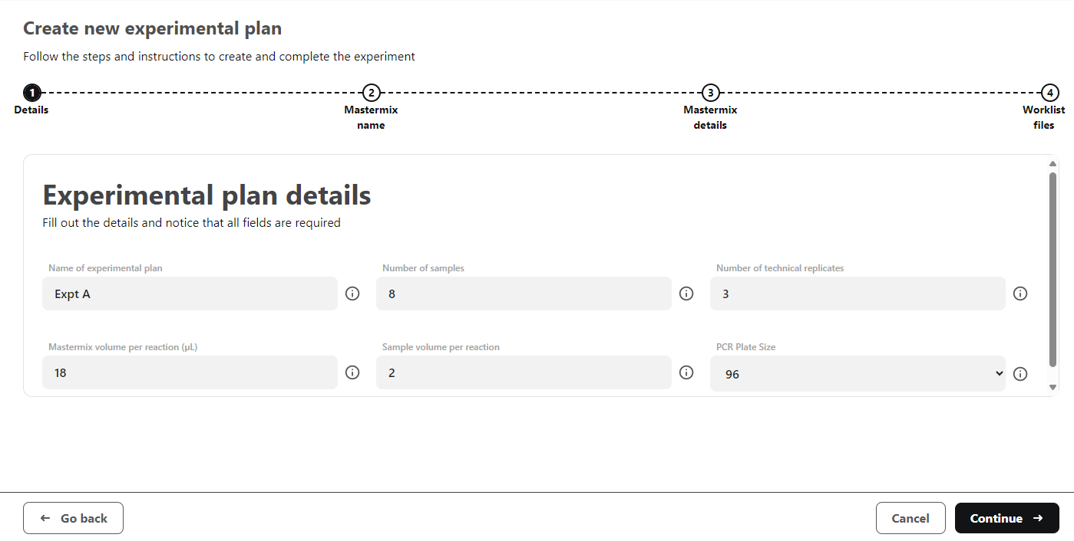

### Type in Mastermix name and click <Continue>.

### Add mastermix details by entering the values in each column or by selecting values from the drop-down. Load mastermix name in first window, click “Next”. Load mastermix protocol for a mastermix, one reagent at a time. Load reagent, one at a time, to the mastermix as necessary using the “Add reagent” icon. Add them in the order as you would want the robot to prepare the mixture. Each section is described in more detail below.

* Source – the identity of the reagent (i.e. water, buffer, dNTPs, DNA pol, etc)
* Concentration unit – drop down menu with options for concentration value will apply to both the final and stock concentration inputs
* Final and stock concentration – number, must correlate to concentration unit chosen
* Tip washing – Yes/No, select “Yes” if the reagent is viscous (i.e., enzyme in 50% glycerol, dextran, etc)
* Liquid type – drop down menu that correlates with the respective liquid class.
* Dispense type – drop down menu for to select for either Surface_Empty or Jet_Empty. We recommend using “Jet_Empty” for the first reagent in a mastermix (typically water) and “Surface_Empty” for the rest. For more information, refer to definition in Section 8.5

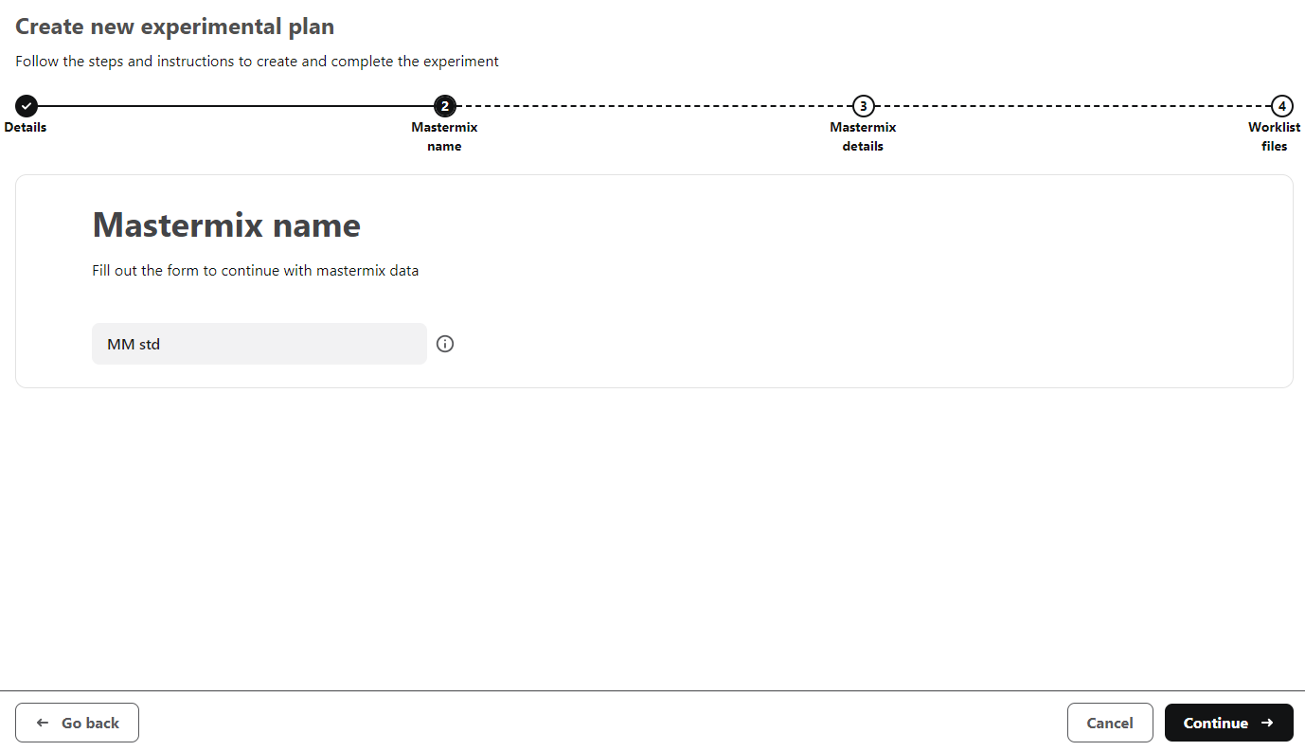

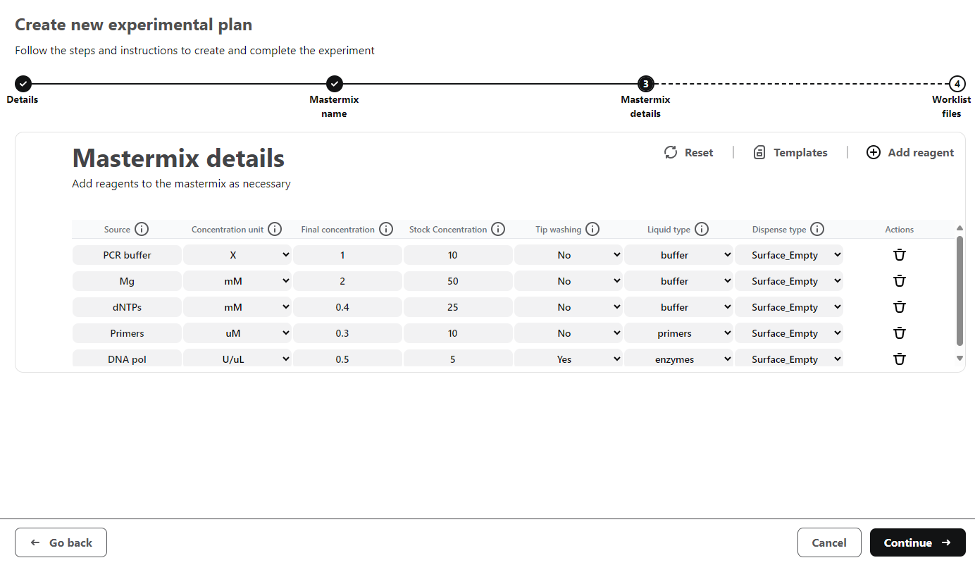

### Mastermixes can be copied and/or edited once loaded into the app. To edit, select the pen icon under the “Actions” tab. To copy, select the copy icon. Mastermixes can also be deleted or renamed by clicking the trashcan or dropper icon.

### Once the experimental plan and mastermixes are loaded, select “Generate Worklist” to move on to the next step.

### Download mastermix and sample worklists by clicking the “Mastermix worklist” and “Sample worklist” icons. These files are .csv files. Note that the web app output is a CSV UTF-8 (which will not be recognized by the Hamilton software). Before using, make sure to save file as *plain .csv* file.

### Download and save experimental data plan by clicking “Export” button. This file is a .txt file and contains all the experimental information to help with one or more of the following:

* Import existing experimental plan to make edits for a new experiment
* Import existing experimental plan to use the worklist viewer when setting up an experiment

*DO NOT make edits to this file. Changes in the format of this file will render this file unusable by the app.*

### Load interactive Worklist Viewer by selecting “View Experimental Plan”. You can also load a different (previously exported) experimental plan once in the Worklist Viewer if desired.

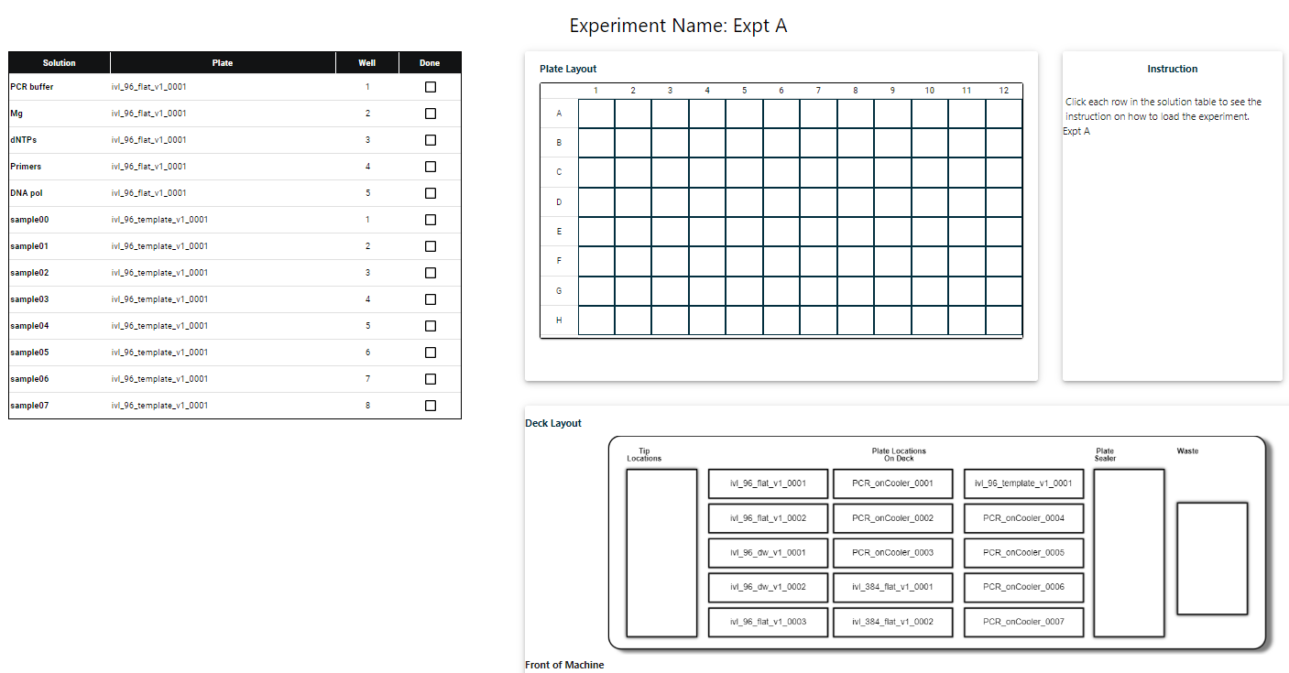

**The worklist viewer has five sections:**

1. *Reagent loading section* – This section includes the list of reagents to be added to run the experiment. It includes solution name (based on user input), plate name, well number, and a check box to indicate when a reagent has been loaded. Click on a given row to highlight locations in the plate layout and deck layout.
2. *Plate Layout* – Shows the layout of a given plate, 96 or 384. When a given reagent is highlighted, the corresponding well will be highlighted in black.
3. *Deck Layout* – Shows the layout of the deck, with the corresponding plate names used by the robot to identify plate locations. Similar to the plate layout, the plate corresponding to a specific reagent will be highlighted in black when that reagent is selected.
4. *Instructions* – When one row in the solution section is selected, instructions will include the solution name, the volume to be pipetted, and the well and plate ID. This can be used by the user to know what to load where, and in what volume.

# Records

This SOP does not generate any records.

# Document Revision History

|  |  |  |  |  |
| --- | --- | --- | --- | --- |
| **REV.#** | **DATE** | **AFFECTED SECTNS.** | **CHANGE DESCRIPTION** | **AUTHOR/OWNER** |
| 00 | 01 July 2022 | N/A | (Initial Release) | Caitlin Anderson |
| 01 | 5 October 2022 | Section 9 | Section has been updated to include instructions on using the RoboNAAT Worklist Generator Web App. | Caitlin Anderson |
| 02 | 16 September 2024 | All | Update for new software | Jason Cantera |
|  |  |  |  |  |

Only the four most recent revisions are listed.

*<EOF>*